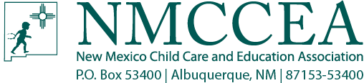

National Administrator Credential (NAC) NMCCEA Registration Form
Cost: (CIRCLE ONE) $700 Non-Members
$600 Members
$50 off Multiple Registrations (for same center)

Dates of Training:______________________________________________________________
Attendees Name:______________________________________________________________
Organization Name:____________________________________________________________
Address:_____________________________________________________________________
City:____________________________________________State:___________Zip:__________
Daytime Phone (______)_____________________Fax:(_______)________________________
Attendee’s Email_______________________________________________________________
Registration is limited to the first 20 students. Confirmation letters will not be sent unless payment is received and cleared.
***Credit card fee: Please be aware that there will be an additional 3% fee charged to all credit card transactions as of October 1, 2014
Cancellation Policy: If you need to cancel you must call NMCCEA at 505-239-0660 two (2) weeks in advance or the registration CANNOT be refunded. Please sign and date that you have read and understand the cancellation policy.

Signature:______________________________________Date:___________________________
Credit Card Number:
Expiration Date:
Print Name on Card:
Signature:
Billing Address for Card:
Please return form and check to:
NMCCEA
PO BOX 53400
Albuquerque, NM 87153-3400
Or
You can FAX to 888-920-8868. We will send you an email receipt to notify FAX receipt.
A confirmation email will be sent out when payment is received and will give the exact location of the class and materials to bring.

